**NZAVS Economic Games – Wave 2 – Wording (27.08.2020)**

Please re-enter your confidential participant number

Top of Form

Please re-enter your confidential participant number below. This can be found in your original email. It should be in the form AAA11 (three capital letters and two numbers).



Next

## Welcome

Top of Form

This is a study of **how people interact and make economic decisions in groups**. Please read the following participant information sheet carefully.

### **Participant Information Sheet**

**Project title:** The NZAVS Economic Decisions Project

**Name of Principal Investigator:** Professor Chris Sibley

**Researcher introduction**

Our research team consists of Professor Chris Sibley, Professor Quentin Atkinson, Professor Ananish Chaudhuri, and PhD student Scott Claessens at the University of Auckland. This research is funded by a Royal Society of New Zealand Marsden Fund grant.

**Project purpose and invitation**

The purpose of this project is to assess how people interact and make economic decisions in groups. You have been invited to participate in this study because you are a participant in the New Zealand Attitudes and Values Study, and you have agreed to participate in an additional online study. You must be at least 18 years old to participate. Participation in this study is voluntary.

**Project procedures**

In this study, we will ask you to make a series of decisions in a number of different tasks. In almost all of these tasks, you will be grouped with one or more other participants in this study. You will not learn the identity of any of these other individuals at any point either during or after the conclusion of the study, and they will not learn your identity.

The instructions for the tasks are simple, and based on the decisions that you make you will be reimbursed an appreciable amount of money. However, this amount will depend on the decisions that you make and the decisions made by the other individuals you are interacting with. You will need to make a series of decisions that differ from one task to the next. So please read the instructions carefully. We will ask you and every other participant to answer some comprehension questions before each task, to make sure that everyone understands how the tasks will work.

The entire study will take approximately one hour; possibly less. Please make sure that you have that time at your disposal. We will reimburse everyone $20 simply for participating in the study, as a thank you gesture for volunteering. We will also reimburse an additional amount depending on the decisions made by you and others undertaking the same task. This additional amount can vary from $10 to $35. However, on average we expect this bonus to be around $25. This means that, on average, a participant can expect an overall reimbursement of around $45. But the actual full amount may well be different based on the decisions you and others make.

Please understand that you will only be reimbursed this additional amount if you complete the study. If for some reason you are unable to complete the study in the allotted time, then you will only be reimbursed the initial $20 for participation.

*Please note: For reimbursement, the University of Auckland cannot apply withholding tax. It is therefore your responsibility to consider the tax treatment of this reimbursement, and determine whether you should include this amount within your annual tax return or personal tax summary.*

There are no known physical or psychological risks associated with this research.

**Data storage/retention/destruction/future use**

The data will be used for a PhD thesis, and to generate results for publication in scholarly journals. Data will be stored in electronic format on a password protected University of Auckland computer, backed up and stored on the University of Auckland server. All journals now require that such data be made available to interested researchers for purposes of replication and verification. Therefore, we intend to store the electronic data for the foreseeable future, so that they can be made available to any researcher who wishes to double-check our work or build on it. Reimbursement data (your name and bank account information) will be decrypted on a local computer, used for online bank transfers, and then permanently deleted immediately after transferring the reimbursements.

**Right to withdraw from participation**

Participation in this study is voluntary. You may withdraw from the study at any time without citing any reason. You can also withdraw from the study at a later date by emailing us (nzavs@auckland.ac.nz). In that case, we will delete any data pertaining to your decisions. Should you wish to do this, you must let us know within four weeks of your day of participation. You will need to tell us the date of your participation as well as your confidential participant number.

**Anonymity and confidentiality**

You have been given a confidential participant number, in the format ‘AAA11’ (three capital letters and two numbers). Your participant number will be used throughout the study, and will only be able to connect you to your previous NZAVS responses, which are anonymised.

At the end of the study, we will ask you for your full name and bank details to reimburse you. To protect your anonymity, this information will be stored in an encrypted data file, which can only be accessed with a private key stored on a separate password-protected computer. This information will only be used for reimbursement purposes, and will be permanently deleted immediately after the reimbursement is processed by the University of Auckland. After reimbursement, nothing will directly connect you to your name or bank details.

Your data will be kept confidential, and this information will be stored safely in a file on the computer. Only the researchers involved will have access to the data, which will be used only for the purposes of this dissertation, and possibly for future scholarly publications.

**Contact details**

If you have any questions or concerns about this study, please contact Professor Chris Sibley (Phone: 09 923 8353; Email: nzavs@auckland.ac.nz) in the School of Psychology. You may also contact Professor Suzanne Purdy, Head of the School of Psychology (Phone: 09 923 2073; Email: sc.purdy@auckland.ac.nz).

For any queries regarding ethical concerns, you may contact the Chair, The University of Auckland Human Participants Ethics Committee, The University of Auckland, Office of the Vice Chancellor, Private Bag 92019, Auckland 1142. Telephone: 09 373 75 99 ext. 83711. Email: ro-ethics@auckland.ac.nz

Approved by the University of Auckland Human Participants Ethics Committee on 19/07/2018 for 3 years. Protocol Number: 021666

I have read the Participant Information Sheet, have understood the nature of the research and why I have been selected. By participating in this online study, I am indicating that I understand that:

* I am agreeing to participate in this study.
* I am at least 18 years old.
* This is an online study that will take approximately one hour to complete.
* I will be reimbursed an initial $20 as a thank you gesture for volunteering my participation.
* I will be reimbursed an additional amount ranging between $10 and $35 (expected average $25) based on the decisions that other participants and I make in this study. This additional amount will only be reimbursed if I complete the study; otherwise, I will only get the initial $20.
* For this reimbursement, the University cannot apply withholding tax. It is therefore my responsibility to consider the tax treatment of this reimbursement and determine whether I should include this amount within my annual tax return or personal tax summary.
* My participation is completely voluntary.
* I am free to withdraw my participation at any time, without giving reason.
* At the end of the study, I will be required to submit my full name and bank account number for reimbursement purposes.
* My name and bank account number will be stored in an encrypted data file. It will be used solely to reimburse me, and will then immediately be deleted.
* My responses will remain completely anonymous.
* Though data collected from this study may be presented at research conferences and published in scholarly outlets, my identity will never be revealed.

**Click Next to provide informed consent to take part in this study.**

Next

General Instructions

Top of Form

**PLEASE READ THESE INSTRUCTIONS CAREFULLY!**

Thank you for participating in our study.

In this study, you will take part in **eight tasks**. These tasks all require you to make economic decisions in groups.

Each task will proceed as follows:

1. **Instructions.** You will read the instructions for the task. The instructions are different for every task, so make sure you read them carefully.
2. **Comprehension.** You will then answer a short comprehension question about the instructions, to make sure you have understood them.
3. **Decision(s).** Finally, you will make the decision(s) for the task. The decisions you make in each task will determine your bonus reimbursement for the study.

Some tasks will have different "roles" for different participants. We will ask you what you would like to do in each possible role.

The payoffs for each task will be given in points. Every ten points will be worth $0.35 at the end of the study. For example, a task for 100 points has $3.50 at stake.

**After you have completed all the tasks,** we will randomly match your decisions to the decisions of other **real people** taking part in this study at the same time. For each task, you will be matched with one or more other people. You will be re-matched randomly for every task, so the chance of you interacting with the same person in consecutive tasks is very small. You will never learn the identity of the people you are matched with. They will never learn your identity. The money that you are reimbursed from these tasks depends on the decisions that you and the other participants make.

**Every task will count towards your final payoff.** At the end of the study, after matching your decisions with those of other random participants, we will calculate what you earned in each task. The sum total of all these earnings will determine your bonus reimbursement from the study.

*Remember, this is not a survey you can pause and come back to later. The timer at the top of the screen will tell you how long you have left to complete the study, so please stay focused. Otherwise, other participants will have to wait for you.*

**Please click Next to begin the tasks.** Next

## Begin the tasks

Top of Form

**You will now begin the tasks.** The decisions you make from now on will determine how much you are reimbursed from this study.

Please click Next to continue to the first task.

Next

## Task 1 of 8

Top of Form

Please read the following instructions carefully.

### **Instructions**

In this task, you have to make a number of estimates. The number of points you earn in this task depends on how accurate your estimates are.

The task consists of 5 rounds. At the beginning of each round, you will observe an image showing a number of animals. The image will disappear after 6 seconds. Once the image has disappeared, you have to enter an estimate of **how many animals were displayed** within 15 seconds. The more accurate your estimate, the more points you can earn. This is your estimate for **Part A** of a round.

Once you have entered your estimate, **Part B** of the round begins. You can observe the estimate of **another participant**. Over 100 people participated in a previous session in which they completed this task. In each round, you can observe the Part A estimate of one of these previous participants. Previous participants saw the same image as you. They also saw it for six seconds. After the image disappeared, they also had to estimate how many animals were displayed. They could also earn more points if their estimate was more accurate.

You then have to enter a **second estimate** within 45 seconds. You can enter the same estimate as before, or adjust it as you wish. This is your estimate for Part B of a round. Once you have entered your Part B estimate, the round is over and a new round begins.

*Note: if you do not enter your estimate within the time limit, you will earn 0 points for this task.*

To calculate your earnings, the computer will randomly select 1 of the 5 rounds of this task. Then, the computer will randomly select Part A or B. Your estimate for that part is used to calculate **your earnings for this task**. If you estimated the number of animals exactly right, you earn 100 points. For each number that you are off, we subtract 5 points. Your earnings cannot become negative. For example, if the actual number of animals in the image was 60, and you estimate 53, you were 7 off. We subtract 7 x 5 = 35 points, so you would earn 100 - 35 = 65 points.

Here is an example image from the task:

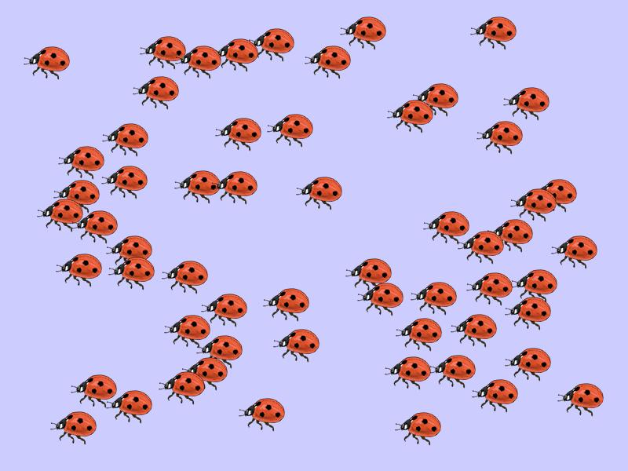

Next

Task 1 of 8

Top of Form

Before the task, please answer the following comprehension question carefully.

Once you have entered your estimate, you can observe the estimate of a previous participant who completed this task before, and then make a second estimate.

* True
* False

Next

## Task 1 of 8

Top of Form

**Correct!** Once you have entered your estimate, you can observe the estimate of a previous participant who completed the task before, and then make a second estimate.

Click Next to make your estimates.

Next

## Task 1 of 8 - Round 1 of 5

Top of Form

The task starts now.

When you click below, an image will appear showing a number of ants.

After 6 seconds, the image disappears. A box will appear in which you have to estimate how many ants there were. You have to enter your estimate **within 15 seconds**.

Click below when you are ready.

Next

## Task 1 of 8 - Round 1 of 5

Time left: **0:15**

Top of Form

How many ants were shown in the image?

Next

## Task 1 of 8 - Round 1 of 5

Time left: **0:45**

Top of Form

Your Part A estimate of **60** has been recorded.

Now, we show you the Part A estimate of a participant who has completed this task before. This previous participant saw the same image that you just did. They also saw it for 6 seconds. Their estimate was **75**. You can now enter your Part B estimate below.

How many ants were shown in the image?

Next

This repeats for four more rounds, with different animals in each

## Task 1 of 8

Thank you, your decision(s) for this task have been saved. After all 8 tasks are completed, your decisions will be matched with the decisions of other real NZAVS participants.

Remember, the points in these tasks are being converted to **real money** that you will earn after the study is over.

Please click Next to continue.

Next

## Task 2 of 8

Please read the following instructions carefully.

### **Instructions**

In this solo task, you will decide how to allocate 30 balls between two buckets.

Your task is to put each of the balls, one-by-one, into the two buckets on the screen.

You will allocate each ball by clicking either the button for Bucket A or the button for Bucket B.

For each ball you put in Bucket A you will receive **2 tokens**, and for each ball you put in Bucket B you will receive **1 token**.

**The rule is to put the balls in Bucket B.**

Next

## Task 2 of 8

Before the task, please answer the following comprehension question carefully.

How many tokens will you receive for each ball you put in Bucket A?

* 2 tokens
* 1 token

Next

## Task 2 of 8

**Correct!** For each ball you put in Bucket A, you get 2 tokens.

Click Next to make your real decisions.

Next

Task 2 of 8

Remember, for each ball you put in Bucket A you will receive **2 tokens**, and for each ball you put in Bucket B you will receive **1 token**.

**The rule is to put the balls in Bucket B.**

Please now allocate the balls to the buckets you choose using the buttons below. You must allocate all the balls to continue.

**Balls remaining: 30/30**  Bucket A  Bucket B

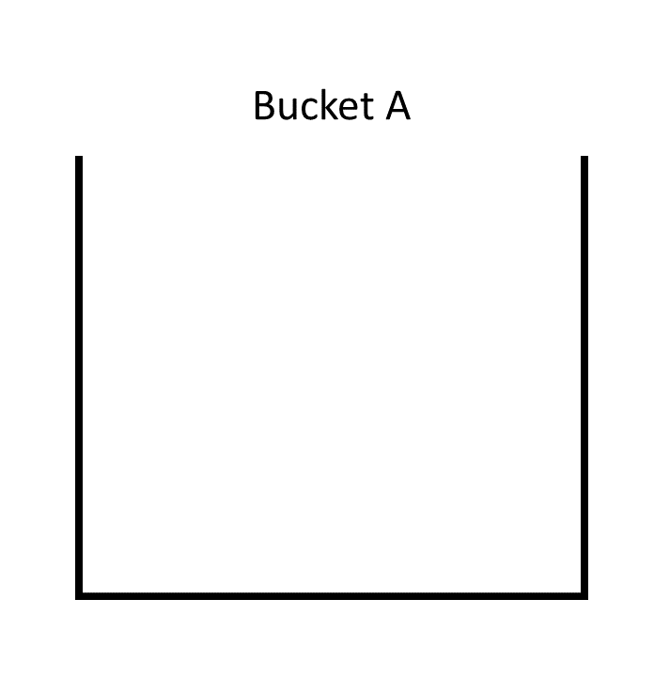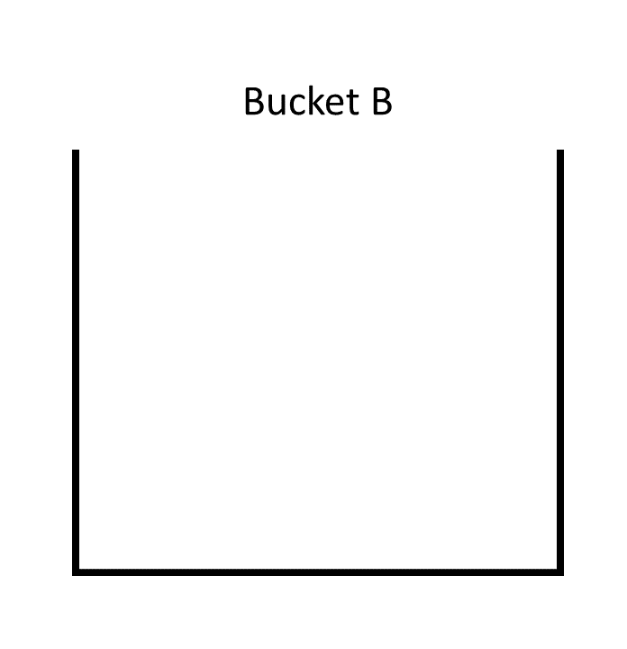

## Task 2 of 8

Thank you, your decision(s) for this task have been saved. After all 8 tasks are completed, your decisions will be matched with the decisions of other real NZAVS participants.

Remember, the points in these tasks are being converted to **real money** that you will earn after the study is over.

Please click Next to continue.

Next

## Task 3 of 8

Please read the following instructions carefully.

### **Instructions**

In this task you are matched with one other person.

One of you will be Person A, the other will be Person B.

Both of you start with 50 points.

First, Person A makes a choice, then Person B responds.

1. Person A can choose to transfer their 50 points or not. If Person A transfers 50 points then it is TRIPLED and given to Person B (so Person B now has 200 points).
2. Person B can then choose how many of the points they want to transfer back to Person A (between 0 and 150). This latter amount is not tripled.

The graphic below shows a summary of the task:

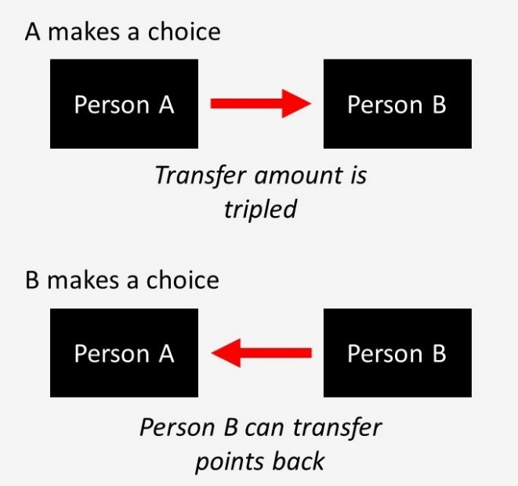

Next

## Task 3 of 8

Before the task, please answer the following comprehension question carefully.

What happens if Person A transfers 50 points and Person B transfers back 25 points?

* Person A earns 25 points, Person B earns 175 points
* Person A earns 50 points, Person B earns 50 points
* Person A earns 100 points, Person B earns 100 points

Next

## Task 3 of 8

**Correct!** If Person A transfers 50 points, those 50 points are tripled and given to Person B (so Person B now has 200 points). If Person B transfers back 25 points, they end the task with 175 points. Person A ends the task with the 25 points that Person B transferred.

Click Next to make your real decisions.

Next

## Task 3 of 8

If you are Person A, do you want to transfer your 50 points to Person B?

* No transfer
* Transfer 50 points

Next

Task 3 of 8

If you are Person B and Person A transfers you 50 points (which is tripled to 150), how many points do you want to transfer back to A? [0 - 150]:

Next

## Task 3 of 8

Thank you, your decision(s) for this task have been saved. After all 8 tasks are completed, your decisions will be matched with the decisions of other real NZAVS participants.

Remember, the points in these tasks are being converted to **real money** that you will earn after the study is over.

Please click Next to continue.

Next

## Task 4 of 8

Please read the following instructions carefully.

### **Instructions**

In this task you are matched with three other people.

All of you start with 100 points.

Each of you will choose how much of these 100 points to contribute to a group project, and how much to keep for yourself.

All individuals decide at the same time.

All contributed points are doubled and split evenly among the group.

Thus, for every 2 points you contribute, you only receive one point from the project. So contributing more points always increases your groups' total payoff, but you always end up with more money if you contribute less.

The graphic below shows a summary of the task:

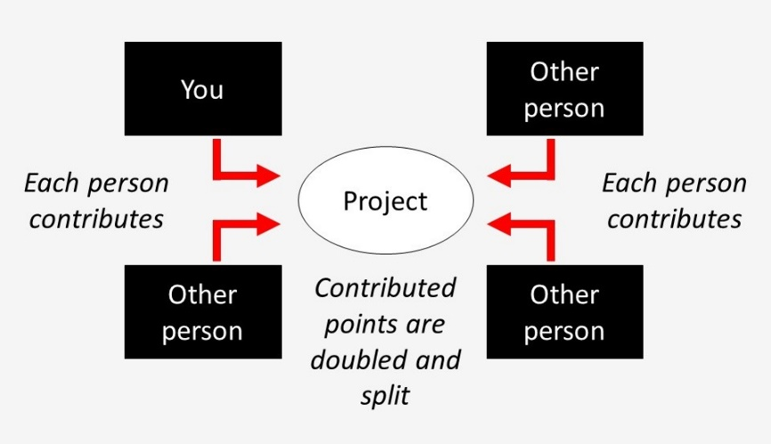

Next

## Task 4 of 8

Before the task, please answer the following comprehension question carefully.

What contribution BY YOU maximises payoffs for the GROUP? What about for yourself?

* Contributing 100 maximises payoffs for both the group and myself
* Contributing 0 maximises payoffs for both the group and myself
* Contributing 100 maximises payoffs for the group but contributing 0 maximises my own payoff

Next

## Task 4 of 8

**Correct!** Contributing all 100 of your points maximises the payoffs to the group, but contributing 0 points maximises the payoffs for yourself.

Click Next to make your real decision.

Next

## Task 4 of 8

How many points do you wish to contribute to the group project? [0 - 100]:

Next

## Task 4 of 8

Thank you, your decision(s) for this task have been saved. After all 8 tasks are completed, your decisions will be matched with the decisions of other real NZAVS participants.

Remember, the points in these tasks are being converted to **real money** that you will earn after the study is over.

Please click Next to continue.

Next

## Task 5 of 8

Please read the following instructions carefully.

### **Instructions**

In this task you are matched with one other person.

One of you will be Person A, one of you will be Person B.

Person A starts with 100 points and Person B starts with 0 points.

First Person A makes a choice, then Person B responds.

1. Person A will make an offer on how to split the 100 points with Person B.
2. Person B will either accept or reject this offer. If Person B accepts the offer, then B will get the offered amount and A will keep the rest. If Person B rejects the offer then both individuals will get 0 points.

The graphic below shows a summary of the task:

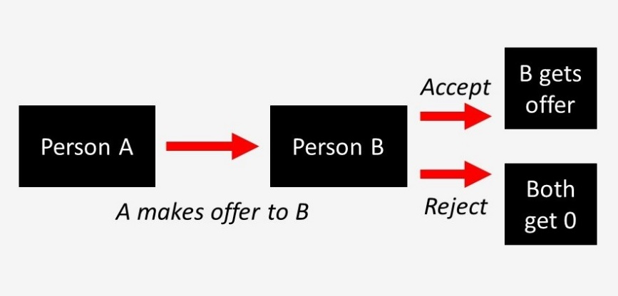

Next

## Task 5 of 8

Before the task, please answer the following comprehension question carefully.

What happens if Person B accepts an offer of 20 points? What happens if Person B rejects this offer?

* If B accepts this offer then A gets 80 and B gets 20, if B rejects then A gets 80 and B gets 0
* If B accepts this offer than A gets 0 and B gets 0, if B rejects then A gets 0 and B gets 0
* If B accepts this offer then A gets 80 and B gets 20, if B rejects then both get 0

Next

## Task 5 of 8

**Correct!** If Person B accepts an offer of 20 points, Person A ends the task with 80 points and Person B ends the task with the 20 points they accepted. However, if Person B rejects an offer of 20 points, both Person A and Person B end the task with 0 points.

Click Next to make your real decisions.

Next

Task 5 of 8

If you are Person A, what amount will you offer to Person B? [0 - 100]:

Next

Task 5 of 8

If you are Person B, what is your minimum acceptable offer? That is, if the offer that Person A gives you is below this, you would reject and if the offer A gives you is above or equal to this, you would accept. [0 - 100]:

Next

## Task 5 of 8

Thank you, your decision(s) for this task have been saved. After all 8 tasks are completed, your decisions will be matched with the decisions of other real NZAVS participants.

Remember, the points in these tasks are being converted to **real money** that you will earn after the study is over.

Please click Next to continue.

Next

## Task 6 of 8

Please read the following instructions carefully.

### **Instructions**

In this task you are matched with one other person.

One of you will be Person A, one of you will be Person B.

Person A starts with 100 points, and Person B starts with 0 points.

This task has one single decision: Person A will choose how many of the 100 points to transfer to Person B.

Person B will get the number of points Person A transfers, and Person A will get to keep the rest.

The graphic below shows a summary of the task:

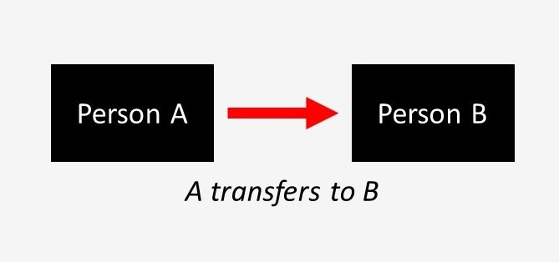

Next

## Task 6 of 8

Before the task, please answer the following comprehension question carefully.

What happens if Person A transfers 20 points?

* A keeps 80 points and B gets 20 points
* Both get 20 points

Next

## Task 6 of 8

**Correct!** If Person A transfers 20 points, Person B gets 20 points and Person A keeps 80 points to themselves.

Click Next to make your real decision.

Next

Task 6 of 8

If you are Person A, how many points will you transfer to Person B? [0 - 100]:

Next

## Task 6 of 8

Thank you, your decision(s) for this task have been saved. After all 8 tasks are completed, your decisions will be matched with the decisions of other real NZAVS participants.

Remember, the points in these tasks are being converted to **real money** that you will earn after the study is over.

Please click Next to continue.

Next

## Task 7 of 8

Please read the following instructions carefully.

### **Instructions**

In this task you are matched with two other people.

One of you will be Person A, one of you will be Person B, one of you will be Person C.

All individuals start with 100 points.

First, Person A makes a choice, then Person C responds.

1. Person A can choose to take or not take from Person B.
2. If A takes, Person B loses 50 points and A gains 30 points.
3. If A takes, then Person C can choose to remove points from A. Person C can remove up to 100 points from A.

Person C must pay 1 point for every 5 points they remove from A. Person B is passive in this task and makes no decisions.

*NOTE: Removed points are completely removed from the task, they are not 'taken' by Person C.*

The graphic below shows a summary of the task:

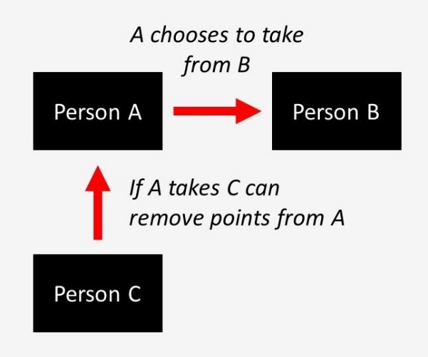

## Task 7 of 8

Before the task, please answer the following comprehension question carefully.

When can Person C remove points from Person A?

* C can only choose to remove points from A if A chooses to take
* C can always remove points from A
* C can never remove points from A

Next

## Task 7 of 8

**Correct!** Person C can only remove points from Person A if they decide to take points from Person B.

Click Next to make your real decisions.

Next

## Task 7 of 8

If you are Person A, will you take from Person B?

* Don't take
* Take

Next

Task 7 of 8

If you are Person C, how many points will you remove from Person A if they take? [0 - 100] (Reminder: if A chooses to take, B loses 50 points and A gains 30 points.):

Next

## Task 7 of 8

Thank you, your decision(s) for this task have been saved. After all 8 tasks are completed, your decisions will be matched with the decisions of other real NZAVS participants.

Remember, the points in these tasks are being converted to **real money** that you will earn after the study is over.

Please click Next to continue.

Next

## Task 8 of 8

Please read the following instructions carefully.

### **Instructions**

In this task you are matched with one other person.

One of you will be Person A, one of you will be Person B.

Both individuals start with 100 points.

This task has two phases. In each phase, both people choose at the same time.

The transfer phase

In the transfer phase, both people will choose to transfer 30 of their points to the other person or not. Any points transferred are doubled and given to the other person.

The penalty phase

In the penalty phase, each person then chooses whether they want to remove up to 50 points from the other person, based on the other person's decision in the transfer phase. For every 5 points someone wants to remove from the other person, they must pay 1 point.

*NOTE: Removed points are completely removed from the task, they are not 'taken' by you.*

The graphic below shows a summary of the task:

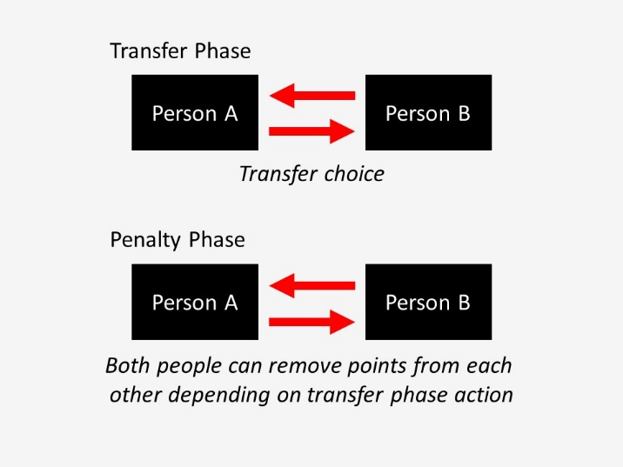

Next

## Task 8 of 8

Before the task, please answer the following comprehension question carefully.

If Person B transfers and Person A doesn't, how many points will they each have at the end of the transfer phase?

* A will have 100 (100 start - 0 transferred), B will have 130 (100 start - 30 transferred + 60 received)
* A will have 160 (100 start + 60 received - 0 transferred), B will have 70 (100 start - 30 transferred)
* Both will have 130

Next

## Task 8 of 8

**Correct!** If Person B transfers and Person A doesn't, Person A ends the transfer phase with 160 points (the 100 points they started with, plus the 60 they received from Person B) and Person B ends the transfer phase with 70 points (the 100 points they started with, minus the 30 points they transferred to Person A).

Click Next to make your real decisions.

Next

## Task 8 of 8

Will you transfer 30 points to the other person?

* Transfer
* Don't transfer

Next

Task 8 of 8

Depending on if the other person transfers, how many points would you like to remove from them?

If the other DOES TRANSFER, I will remove this many points... [0 - 50]:

If the other DOESN'T TRANSFER, I will remove this many points... [0 - 50]:

Next

## Task 8 of 8

Thank you, your decision(s) for this task have been saved. After all 8 tasks are completed, your decisions will be matched with the decisions of other real NZAVS participants.

Remember, the points in these tasks are being converted to **real money** that you will earn after the study is over.

Please click Next to continue.

Next

## Thank you for waiting!

Thank you for your patience! Everyone in the session has now completed the tasks (or time ran out).

We have taken the decisions you made in all 8 tasks, and we've matched them with the decisions of other real NZAVS participants to determine how much money you (and they) earned.

Please click Next to learn the outcome of this matching.

Next

Payoffs

**We have successfully matched you to other real participants.** In the rare event that we could not find a participant to match you with, we have instead matched you with average decisions based on previous research.

For each task, we randomly assigned you to a role (if there were multiple roles) and determined the payoffs for you and the real participant(s) you were matched to.

Below are the results of each of the tasks.

Task 1

We chose a random estimate for this task. You estimated that there were 63 animals. The correct answer was 59.

Your payoff for this task was **80 points**.

Task 2

In this task, you placed 30 balls in Bucket A and 0 balls in Bucket B.

Your payoff for this task was **30 points**.

Task 3

In this task, you were assigned the role of Person A. Both people started with 50 points.

You transferred your 50 points to Person B, which was multiplied to 150 points. Person B then sent back 75 points.

Your payoff for this task was **75 points**.

Task 4

In this task, all four people started with 100 points.

You contributed 0 points to the group project. The other group members contributed 30 points, 30 points, and 30 points. The total number of points was doubled and divided evenly between all people. This was added to your remaining points.

Your payoff for this task was **145 points**.

Task 5

In this task, you were assigned the role of Person B. Person A started with 100 points and you started with nothing.

Person A offered you 40 points. Your minimum acceptable offer of 0 points was below or equal to this, and so you accepted their offer.

Your payoff for this task was **40 points**.

Task 6

In this task, you were assigned the role of Person B. Person A started with 100 points and you started with nothing.

Person A transferred 25 points to you.

Your payoff for this task was **25 points**.

Task 7

In this task, you were assigned the role of Person C. All people started with 100 points.

Person A chose not to take any points from Person B. As a result, you did not remove any points from Person A.

Your payoff for this task was **100 points**.

Task 8

In this task, both people started with 100 points.

In the transfer phase, both people transferred 30 points to the other. These transfers were doubled to 60 points. At the end of the transfer phase, therefore, your payoff was 130 points.

You did not remove any points from the other person for their decision in the transfer phase.

The other person did not remove any points from you.

Your payoff from both phases of this task was **130 points**.

**Your overall payoff from all tasks was 625 points. This means that your bonus for the study is $21.88. This will be added to your initial show-up fee of $20.00, giving you an overall reimbursement of $41.88 for this study.**

If for some reason, your bonus for the study ended up less than $10, then we have rounded it up to $10.

Click Next to see a summary of your reimbursement for the whole study, and to provide your bank account details.

Reimbursement

In total, you will be reimbursed **$41.88** for this study ($20.00 plus $21.88).

In order to reimburse you this money, we now need to ask you for your name and NZ bank account number. This information will be stored in an encrypted data file, which can only be accessed with a private key stored on a separate password-protected computer. This information will only be used for reimbursement purposes, and will be permanently deleted immediately after the reimbursement is processed by the University of Auckland. After reimbursement, nothing will directly connect you to your name or bank details.

Please enter your first name:



Please enter your last name:



Please enter your NZ bank account number. We will transfer your reimbursement into this account, so please make sure it is correct. Please enter it in the following format: 00-0000-0000000-000. This is two numbers, followed by four numbers, followed by seven numbers, followed by three numbers. Dashes are required between the numbers. If your bank account number ends with two digits, you will need to add a leading zero (for example, 12 becomes 012).



**Please double-check that all these details are correct before continuing.** After clicking Next, you *cannot* re-submit this information.

Next

## Reimbursement

These are the details you just submitted to us. Please double-check that they are correct.

First name: **Scott**

Last name: **Claessens**

NZ bank account number: **12-1234-1234567-123**

Are these details correct? If not, please let us know and we will get in touch.

* Yes, these details are correct
* No, these details are not correct

Next

## Feedback

How clear were the instructions for the tasks?

* Extremely clear
* Moderately clear
* Slightly clear
* Neither clear or unclear
* Slightly unclear
* Moderately unclear
* Extremely unclear

If you would like to leave us any feedback about this study, please do so below:



Next

## Future studies

Would you like to be contacted about future studies similar to this one?

* Yes
* No

Next

Please re-enter your participant label

Please re-enter your participant label below. This can be found in your original email.



Next

Please re-enter your participant label

The participant label you entered does not match the one you entered at the start of the study. Please double-check your email, and try entering the participant label one more time. It is very important that you enter the correct participant label, as we will use this to match your responses here with your previous NZAVS responses.



Next

## Thank you for your participation!

The study is over.

Thank you for supplying your reimbursement information. Reimbursement will be processed on the Friday after your participation - we will send you an email when we reimburse you. Please allow five working days from then for the reimbursement to reach you. If you have any questions about this reimbursement process, or the study in general, please get in touch (nzavs@auckland.ac.nz).

You may now close your browser and exit the study. Thank you for your participation.